Steps to be taken when doing and submitting the CSD201 PE:

- Down load given files to your computer.
- Steps to do question 1 (do the same for questions 2 and 3):
Open NetBeans, create a new project named Q1 (or Q1X, Q1Y, ...). Check the item “Create Main Class”, and type Main in the text box behind it as below:
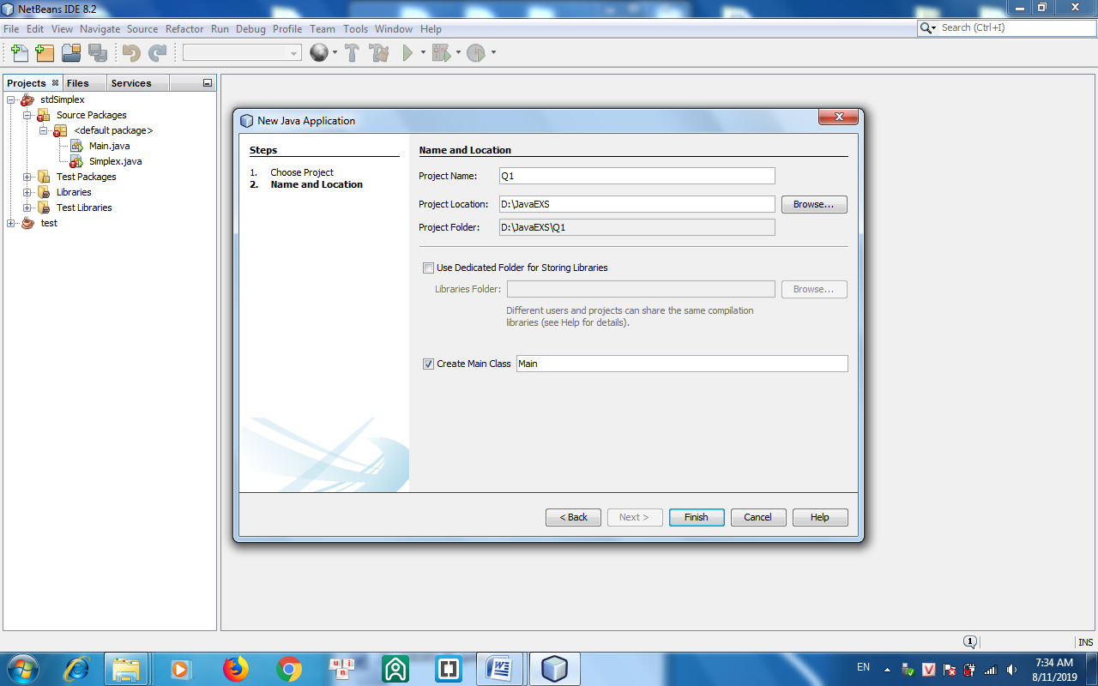
Copy all files in the folder Q1_given into the src folder, then copy the file data.txt to the project folder (outside of src).
- Submittion: Create a folder named CSD201_PE. Copy only projects containing functions you have done into this folder. When submitting, you select the folder CSD201_PE (do not need to compress it).
- The version of Java being used must be 1.7 or 1.8.

Important notice for marking: When marking data will be replaced. Output files f1.txt, f2.txt,... will be compared with the correct output files by the following way: Only file contents are compared. Leading and trailing spaces are not important. Space is important but number of spaces are not. New line is important but number of empty lines is not. Case of letters is important.

The contents may be included in PE:
Linked list (4 marks): Add (first, last, at position), edit, delete, find max, min, sort, reverse. The actions may be performed in the whole list or sub-list, e.g. sort or reverse elements from position k to position h (head’s position is 0).
Binary Search Tree (4 marks): Insert, edit, delete (by copying), traversals , rotate a node (to left, to right), calculate height, count number of nodes. The actions may be performed in the whole tree or sub-trees.
Graph (2 marks): Breadth, depth-first traversals, calculate degree of a vertex, check connectivity, Dijkstra’s shortest path algorithm, find Euler’s cycle or path using stack.

